Lock Screen BlueTooth Java Desktop PoC Assembly
Deployment Guide

Revision History
Author | Revision Number | Date
TCSASSEMBLER | 1.0 | 2014/7/21

1. Organization of Submission 3
2. Application Setup 3
3. Build Scripts Setup 3
4. Window Setup 4
5. Deployment Instructions 4
6. Verification 4
7. Resource Contact List 13

Deployment Instructions

Organization of Submission
conf – this directory contains the configuration files needed by the application.

docs – this directory contains documents needed for this application. One of the documents that you may find here is this deployment document.

lib – contains the libraries needed for this application.

src – contains source files for the implementation of requirements for this competition.

build.properties – configuration file for the ant build. Contains configurable properties that can be modified if desired.

build.xml – ant build files.

Application Setup
- Oracle JDK 6u45
- Ant 1.8+
- Windows7
- BlueTooth device
- Phone with Android and IOS
- BlueCove 2.1.1 http://www.bluecove.org/
- JNA 4.1.0 https://github.com/twall/jna/
- Log4j 1.2.17 http://logging.apache.org/log4j/1.2/

Build Scripts Setup
build.properties – listed here are the properties that you may need to modify to properly run the compilation and deployment of the application.
Variable | Sample | Description
jar.name | LockScreen.jar | The jar name.
mainClass | lockscreen.poc.MainFrame | The main class name.
pin | 111111 | the pin code
checkDevicesInternal | 30000 | the check devices interval  the unit is milliseconds
failedTimes | 2 | if fail defined times it will lock screen.
The configuration is done in the conf/app-template.properties.
When you package application as jar it will read values from build.properties and rename to app.properties and copy to dist folder.
Variable | Sample | Required | Description
pin | @pin@ | no,default value is 111111 | the pin code
checkDevicesInternal | @ checkDevicesInternal@ | no,default value is 30 * 1000 | the check devices interval  the unit is milliseconds
failedTimes | @failedTimes | no,default value is 2 | if fail defined times it will lock screen.
You can find below ant targets in build.xml
Target name | Description
clean | Clean build folder.
compile | compile java sources
jar | package application as jar
run | run the jar

Window Setup
    - Make sure your computer exists windows7 OS and Bluetooth device.
    - Download JDK 6u45 from http://www.oracle.com/technetwork/java/javase/downloads/java-archive-downloads-javase6-419409.html#jdk-6u45-oth-JPR
    - Download Ant 1.8+ from http://ant.apache.org/bindownload.cgi

Deployment Instructions
Step 1: Follow section 4 to setup windows.

Step 2: Modify build.properties to match your configuration.

Step 3: Run ant jar to package application as jar.
You can find generated jar in dist folder

Verification
Because it exists many bluetooth devices but I can just test on limited devices and sometimes the used framework may not work.
For example
BlueCove 2.1.0 not work on windows7 64 with JDK 6 64 bit
https://code.google.com/p/bluecove/issues/detail?id=109
So I change to use BlueCove 2.1.1 SNAPSHOT.
I verify on below computers/devices.
Computers with windows7 64 sp1 with 32/64 JDK 6u45 with built in/USB Bluetooth device.
XIAO MI 2S with Android 4.4
IPAD 2 with IOS 7.1.2
Before verification right click on Bluetooth icon in taskbar and click Show Bluetooth Devices
Make sure there is no device, if you meet error when pairing to devices you can also try to delete it here.
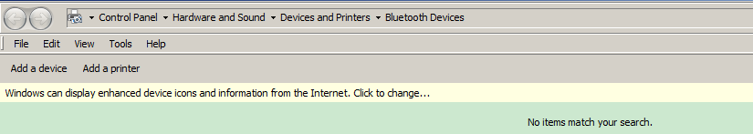
If you meet any error when pairing device please click on Bluetooth icon in taskbar and click Add a device and could add device successfully.
Currently If you pair device once it will still show in device list even if the device is not avaiable(restart application will not remove it from list) so you need to manually remove in above explorer.
  - Verify on Computer without bluetooth devices.
It will just show error dialog when run on computer without bluetooth device.
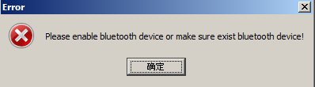
  - Verify on Computer with bluetooth devices.
You will find such dialog firstly you will not see any devices in list.
You can wait checkDevicesInternal/1000(defined in app.properties) seconds
or click refresh button immediately to get latest devices list (currently it will click refresh button and load cached devices when application launching first time).
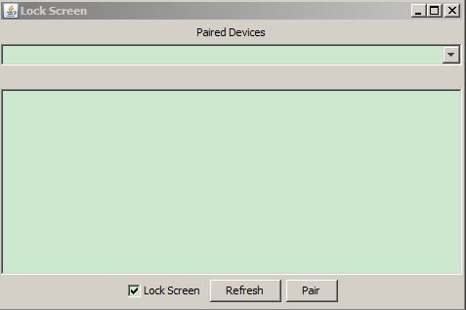
  - Verify by Android Phone
I test on XIAO MI 2S with Android 4.4 actually.
First please turn bluetooth on your phone and make sure it is visible to nearby Bluetooth devices, after it is paired once it may be visible to paired devices only or not visible so please make sure change to be visible to public if you want to see or pair devices.
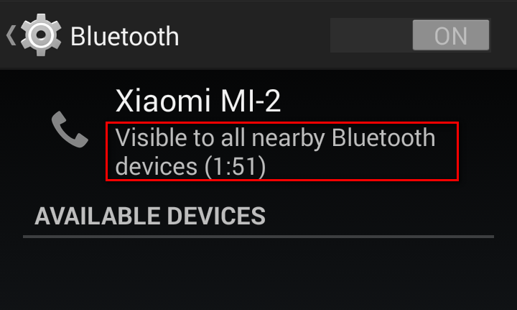
After refresh job is done you will find android phone in list and can view its mac address.
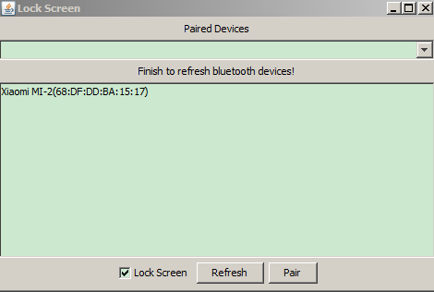
Now you can click Pair button
During my vefirication If I use USB bluetooth device
you can just input pin defined in build.properties(111111 if you not change)
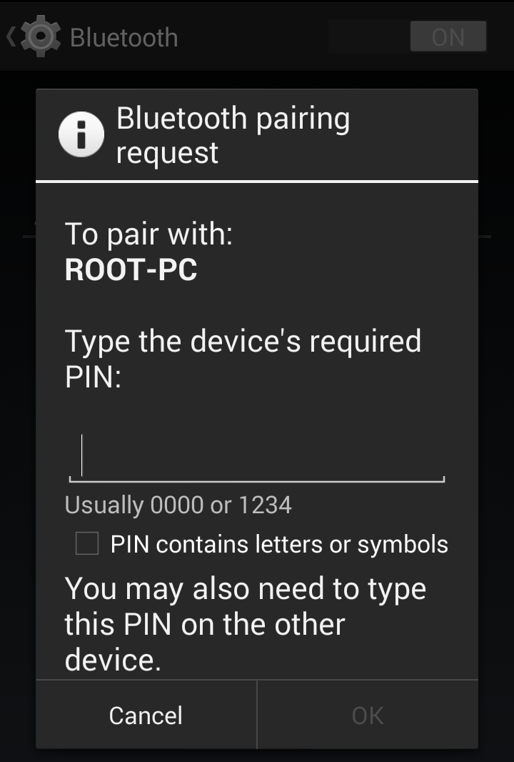
After input right pin you can find device exist in Paired Devices comboBox.
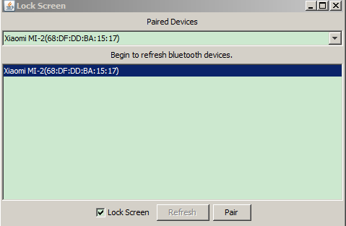
You can find your computer machine name under PAIRED DEVICES of phone
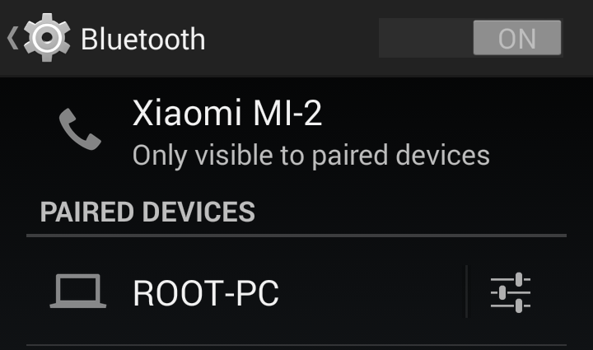
If I use built in bluetooth device
you can just input pin with random number after click pop dialog in windows
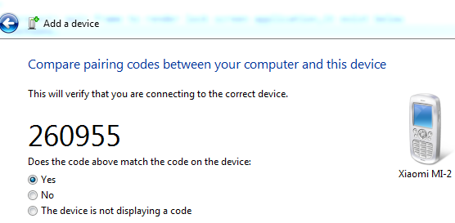
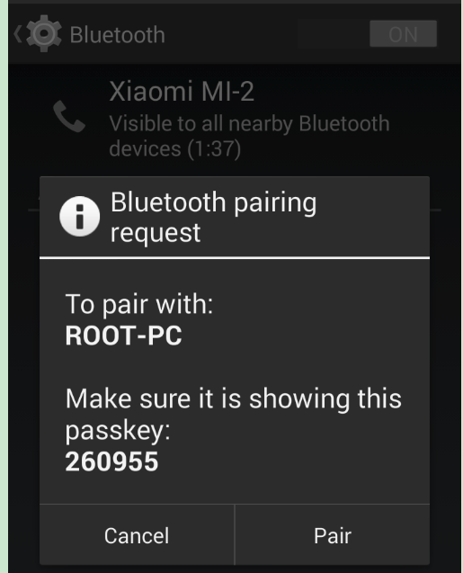
If you check Lock Screen and turn off Bluetooth on your phone
Wait for refresh job to finish and you will find your computer is locked.
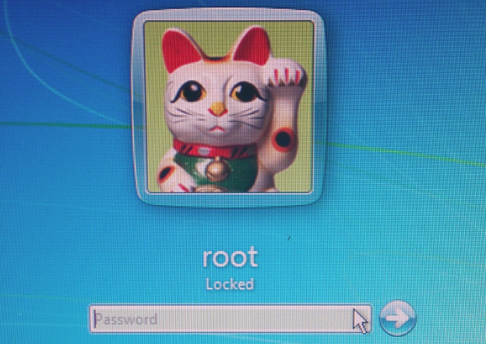
  - Verify by IOS Phone
I test on IPAD 2 with IOS 7.1.2 actually.
The operations are similar to phone with android.
Firstly turn on Bluetooth on phone and make sure device is visible to nearby devices,secondly after device is show on list,pair device with pin code,if pair successfully just test lock function by turning off Bluetooth on phone,so I just give some screenshots.
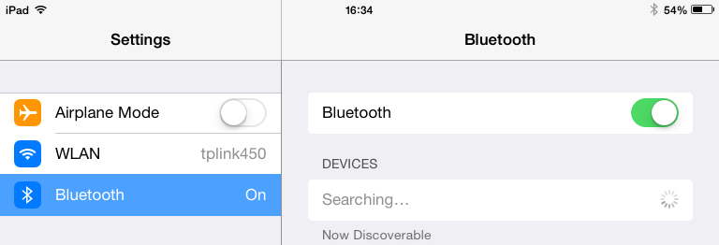
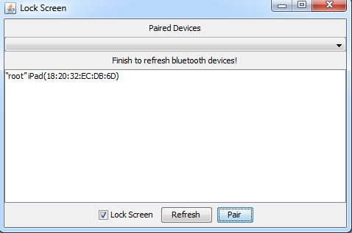
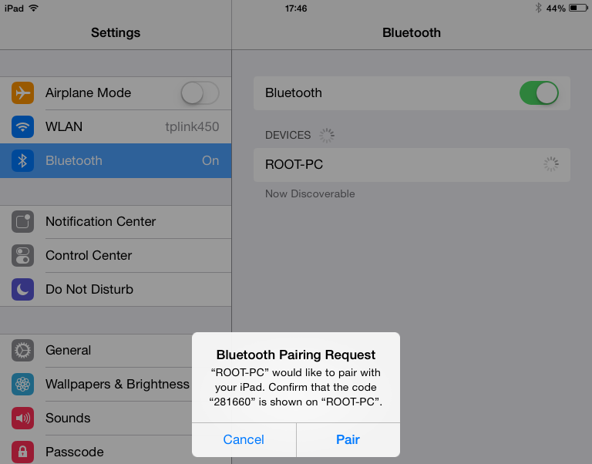
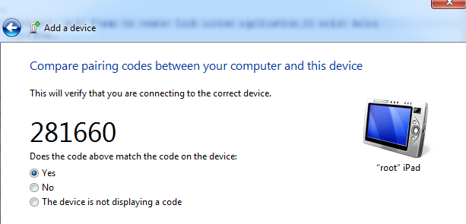

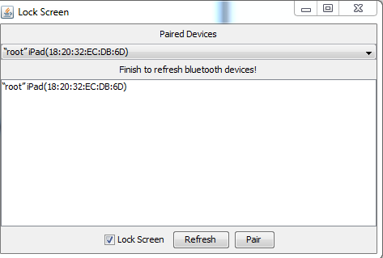
If you check Lock Screen and turn off Bluetooth on your phone/ipad
Wait for refresh job to finish and you will find your computer is locked.
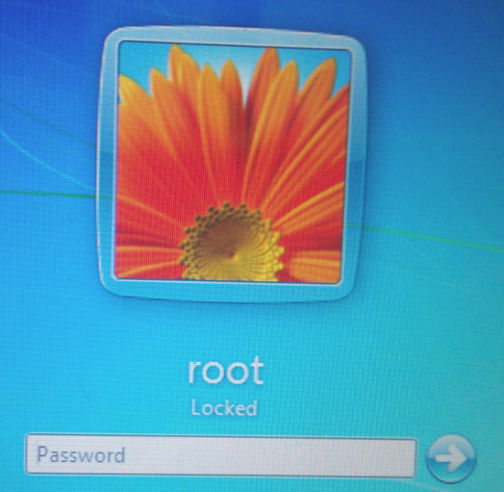
  - Verify with Bluetooth device turned off on computer.
During verification if you turn off Bluetooth device on computer you will see error dialog
with message BT lock is no longer available!.
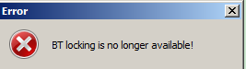
IF you turn on blue device you can refresh again to get device list.
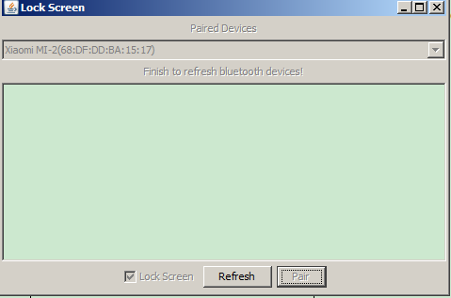

Resource Contact List
Name | Resource Email
TCSASSEMBLER

